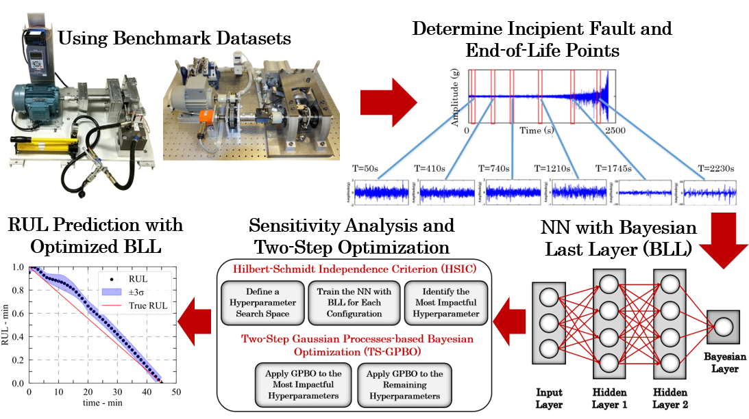

**Publication title:**

Reducing epistemic uncertainty in the prediction of remaining useful life

**Authors:**

Nazir Laureano Gandur, Onur Can Kalay, Stephen Ekwaro-Osire, Marcos Valdebenito, Sergio Lucia, Matthias Faes.

**Links:** -

**Abstract:**

Accurately estimating the remaining useful life (RUL) of mechanical components is a key aspect of maintenance strategies to minimize unscheduled downtime and prevent economic losses or accidents. Ball bearings are mechanical elements that play a critical role in diverse industry applications and hence demand an accurate RUL prediction. Given the importance of accurate RUL prediction of ball bearings, the research question in this paper is: “Can model-related epistemic uncertainty be reduced in the RUL prediction of ball bearings?” To answer this research question, the following objectives were constructed: (1) determine the impact of the neural network (NN) uncertainty quantification on epistemic uncertainty, and (2) evaluate the influence of NN epistemic uncertainty on the RUL prediction. This paper focuses on reducing epistemic uncertainty in RUL prediction using an NN with a Bayesian last layer (BLL) architecture, Hilbert-Schmidt independence criterion-based sensitivity analysis, and Gaussian processes-based Bayesian optimization. By incorporating a BLL, the model combines the expressiveness of NNs with uncertainty quantification of the model’s epistemic uncertainty. The research utilizes the XJTU-SY and PHM 2012 run-to-failure datasets to verify the effectiveness and application value of the proposed method. Results revealed that the proposed method overcomes some of the most recent methodologies on RUL predictions, showing its effectiveness.